Juan Lucas Torres #1795849

Javascript Team project

Testing on Android devices:

·Galaxy S5 emulator.

· Nexus 5x emulator.

· LG Optimus L70 emulator.

The drag and drop of the game draggit didn't work in Android: the images stayed fixed on the screens in every emulator.

The touch screen of the Brickbreaker didn’t work on Android: the user cannot move the bar to be able to play.

All the links worked in every device.

Rotating the screen works properly in every device but the look an feel of the portrait look is too small for the devices size. It works better on landscape version.

Please, see the attached images below for samples and screen resolution tests.

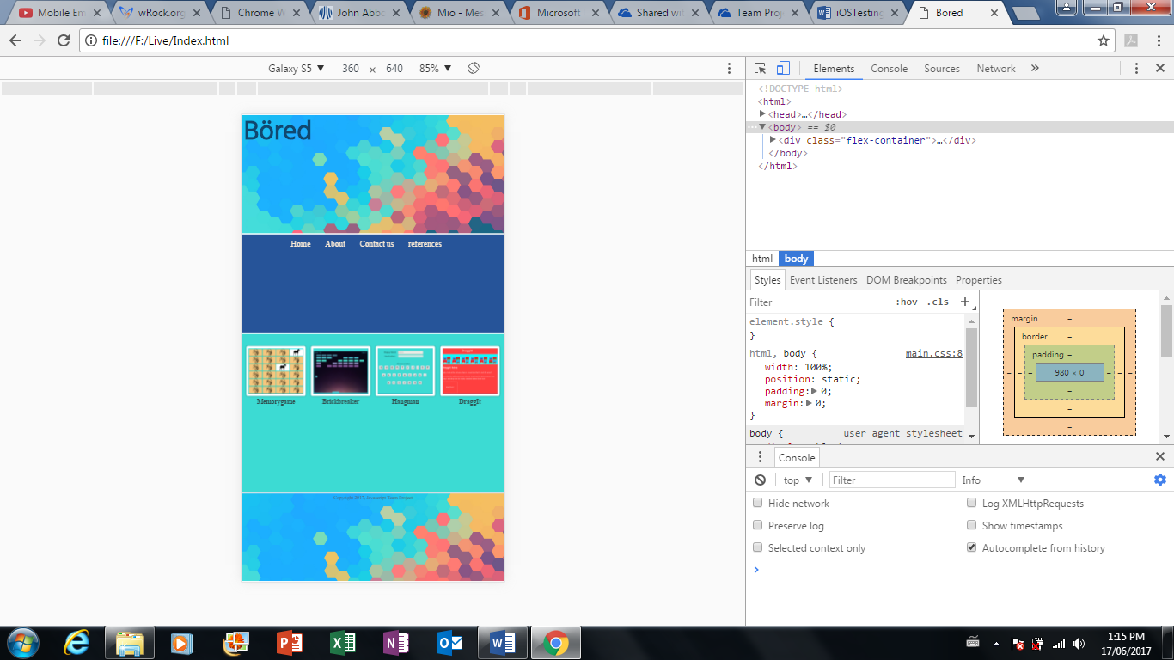Galaxy S5:

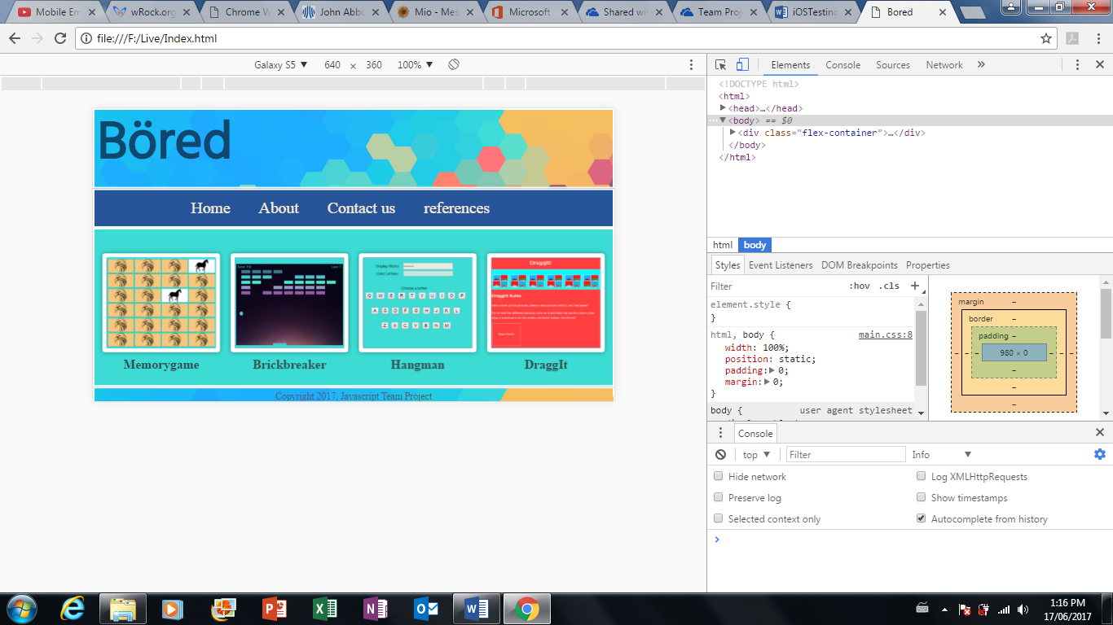

Nexus 5x:

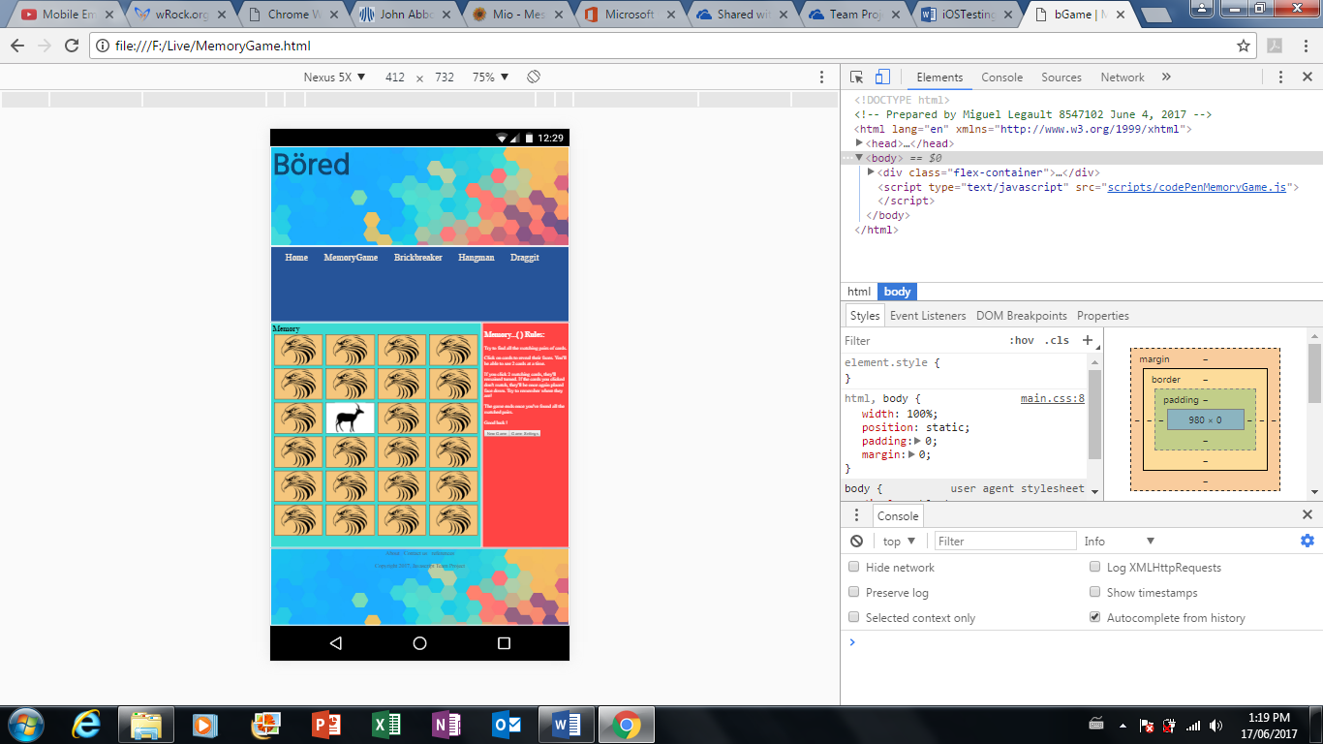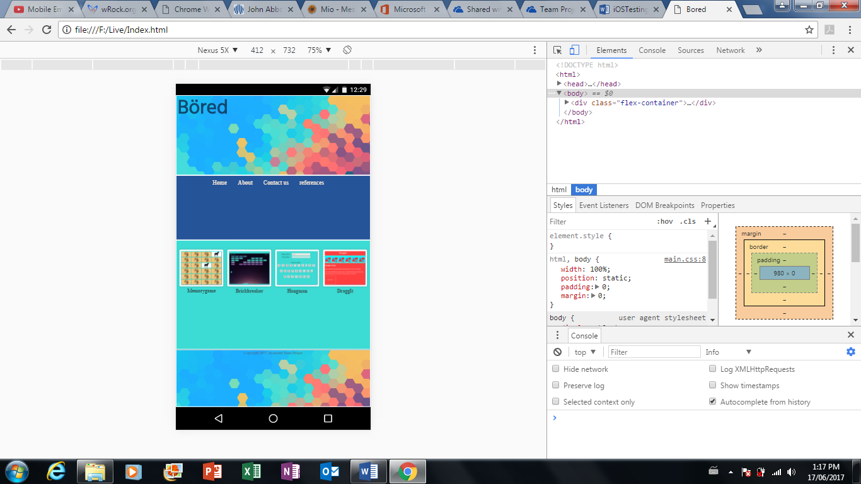

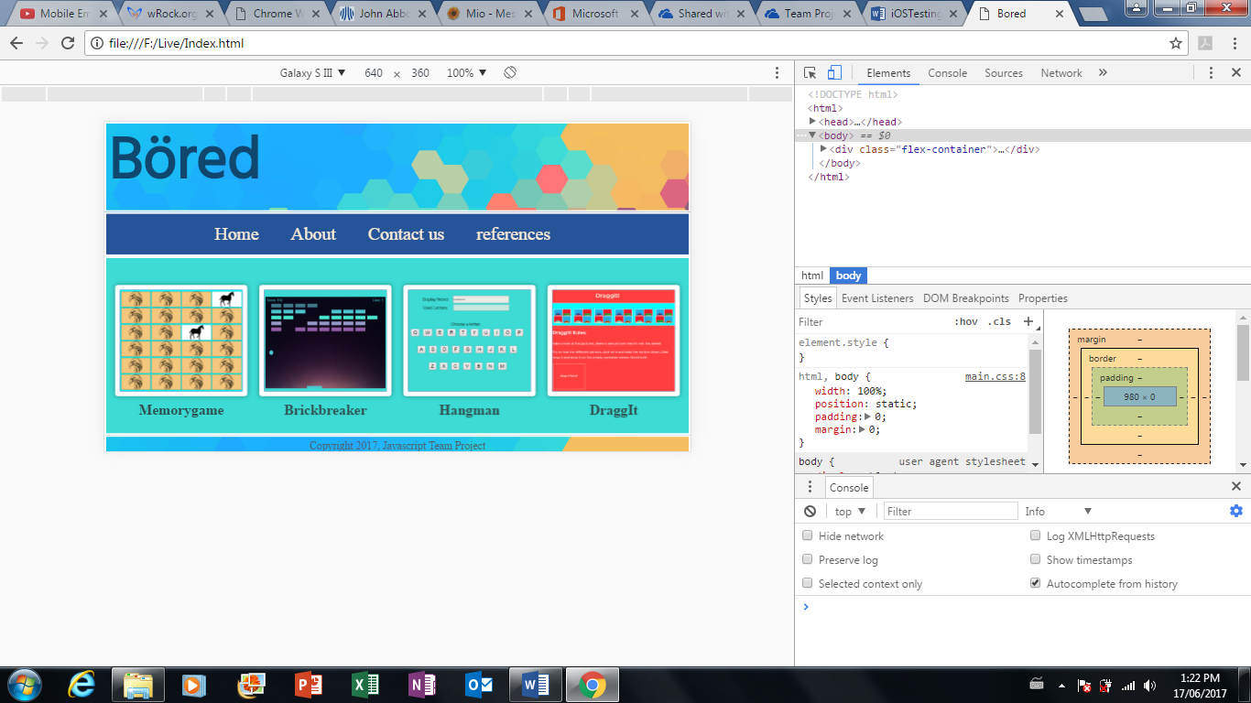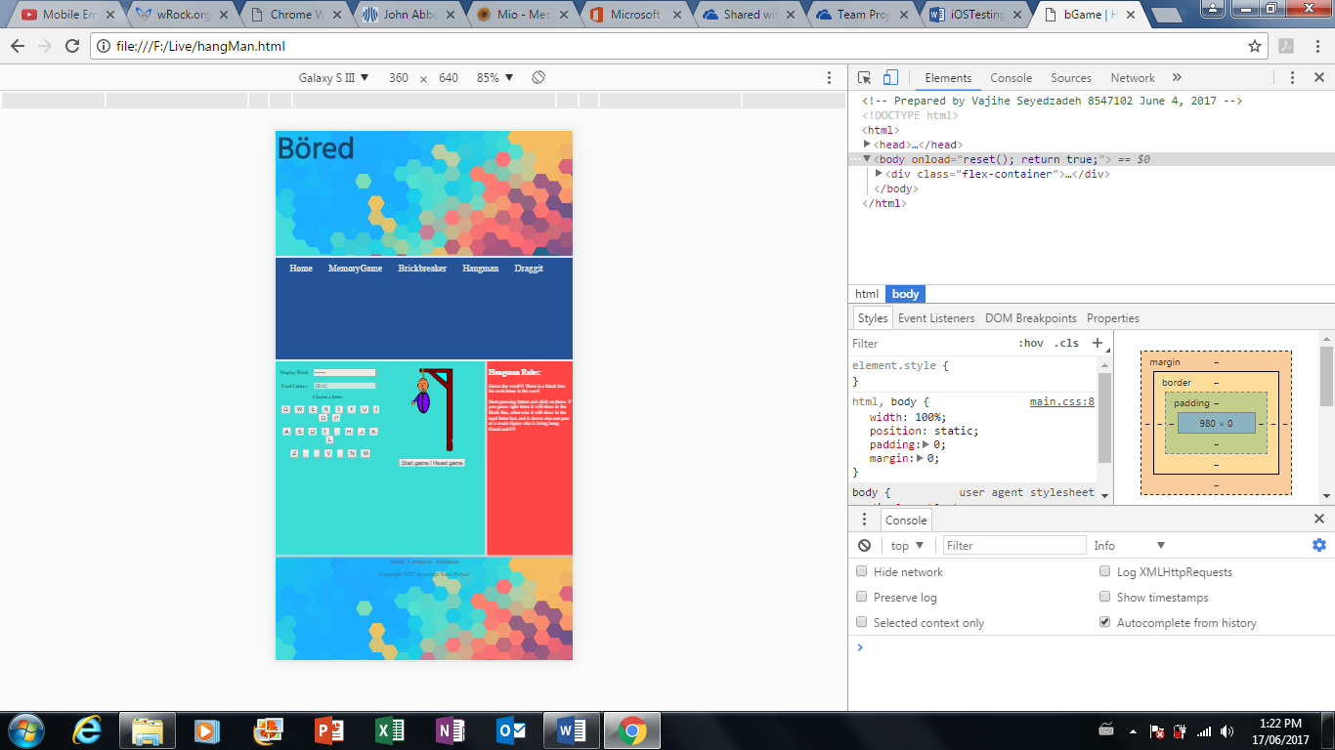LG Optimus L70: